Cisco IPsec VPN Lab (Packet Tracer)
This project demonstrates how to configure a site-to-site IPsec VPN between two Cisco routers using Packet Tracer. The lab includes:
- IPsec configuration with pre-shared keys
- ACL for defining interesting traffic
- Static routing for LAN-to-LAN connectivity
- Verification and troubleshooting commands

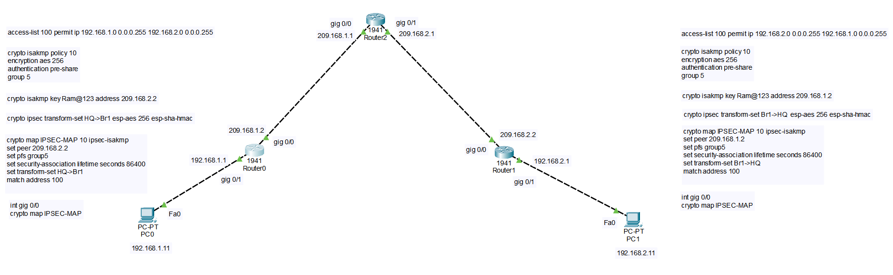
Let’s break down each command in your configuration and explain why it’s needed and what role it plays in building an IPsec VPN:

✅ 1. access-list 100 permit ip 192.168.1.0 0.0.0.255 192.168.2.0 0.0.0.255
- Purpose: Defines “interesting traffic” for IPsec.
- Why needed: IPsec does not encrypt all traffic by default. This ACL tells the router to encrypt packets between the two LAN subnets (192.168.1.0 and 192.168.2.0).
- Key point: If this ACL is missing or wrong, the tunnel will never come up.

✅ 2. crypto isakmp policy 10
- Purpose: Creates an ISAKMP (IKE Phase 1) policy.
- Why needed: Phase 1 establishes a secure channel for negotiating IPsec parameters.
- Options explained:
  - encryption aes 256 → Strong encryption for Phase 1.
  - authentication pre-share → Uses pre-shared key for authentication.
  - group 5 → Diffie-Hellman group for key exchange.

✅ 3. crypto isakmp key Ram@123 address 209.168.2.2
- Purpose: Defines the pre-shared key for the remote peer.
- Why needed: Both routers must have the same key for authentication in Phase 1.
- Key point: If the key or peer IP is wrong, Phase 1 fails.

✅ 4. crypto ipsec transform-set HQ->Br1 esp-aes 256 esp-sha-hmac
- Purpose: Defines the encryption and integrity algorithms for IPsec (Phase 2).
- Why needed: Specifies how data will be protected inside the tunnel.
- Options explained:
  - esp-aes 256 → Encrypts data with AES-256.
  - esp-sha-hmac → Provides integrity using SHA.

✅ 5. crypto map IPSEC-MAP 10 ipsec-isakmp
- Purpose: Binds all IPsec settings together and applies them to an interface.
- Why needed: Without a crypto map, the router won’t know which traffic to encrypt.
- Subcommands:
  - set peer 209.168.2.2 → Remote VPN peer IP.
  - set pfs group5 → Enables Perfect Forward Secrecy for extra security.
  - set security-association lifetime seconds 86400 → Tunnel lifetime (24 hrs).
  - set transform-set HQ->Br1 → Uses the defined transform set.
  - match address 100 → Links the ACL to the crypto map.

✅ 6. int gig 0/0
crypto map IPSEC-MAP
- Purpose: Applies the crypto map to the physical interface.
- Why needed: This is where encryption happens. If you forget this step, the tunnel never activates.

Summary of Why Each Is Needed
- ACL → Defines what to encrypt.
- ISAKMP policy & key → Secure Phase 1 negotiation.
- Transform set → Defines Phase 2 encryption/integrity.
- Crypto map → Combines everything and applies to interface.
- Interface binding → Activates IPsec on the WAN link.

